Title (Calibri 13 font, thick, capitalize first letter of every word)

Name and Surname¹ Name and Surname²

¹ Affiliation, e-mail, ORCID:

² Affiliation, e-mail, ORCID:

Abstract: Abstract should be between 200 and 500 words. Abstract should include aim, material and method, and conclusion. It should be prepared using Microsoft Word format, Calibri 9-point font, and 1-spaced.
Keywords: 3 to 5 keywords should be provided.

1. INTRODUCTION
Manuscripts should be prepared using Microsoft Word format, Calibri 10-point font, single-spaced, 3 cm margin all around, and 8.5”x11” (A4) page setting. Starting from the introduction all the titles in the article should be numbered using Arabic numerals (1,2,3, etc.) and subheadings should be numbered as 1., 1.1., 1.1.2. They should be written in bold and adjacent to the left. Always use endnotes instead of footnotes. Endnotes to the text should be numbered consecutively. Footnotes should be written in Calibri 10 font size and should be placed before the refences. IBANESS follows APA format as citation system.

2. HEADING
The tables should be placed as shown below.

Table 1: Title of the Table
X | Y | Z
X | Y | Z
X | Y | Z
X | Y | Z
Source: APA Format.
Figures and graphs should be placed as shown below.

Figure 1: Title of the Figure
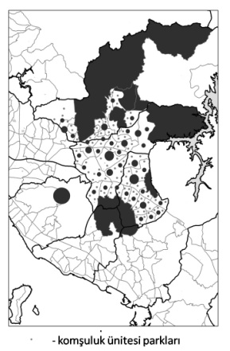
Source: APA Format.

2.1. Subheading

2.2. Subheading

3. HEADING

3.1. Subheading

3.2. Subheading

4. CONCLUSION

REFERENCES

All references cited in the text should be shown under the title “References” at the end of the study. References should be given alphabetically (according to the surnames of the authors) and in their original language at the end of the article.

IBANESS follows APA format as citation system. APA rules are also valid for giving references

