(Calibri 13 Font, Thick, Capitalize First Letter of Every Word)

Name Surname¹ Name Surname²

¹Title, Affiliation, e-mail, ORCID:

²Title, Affiliation, e-mail, ORCID:

Abstract: Abstract should include aim, material and method, and conclusion. It should be prepared using Microsoft Word format, Calibri 9-point font, single-spaced, and justified. Abstract should not exceed 200 words. At least three keywords should be provided.
Key Words: Key Word, Key Word, Key Word

1. INTRODUCTION
Manuscripts should be prepared using Microsoft Word format, double column (except abstract, tables and figures), Calibri 10-point font, single-spaced, 3 cm margin all around, and 8.5”x11” (A4) page setting.
The content of the manuscript should be organized into the following order: Introduction, Material and Methods, Results and Discussion, Conclusions, Acknowledgement (optional) and References.
Starting from the introduction all the titles in the article should be numbered using Arabic numerals (1,2,3, etc.) and subheadings should be numbered as 1., 1.1., 1.1.2. They should be written in bold and adjacent to the left.
Introduction: It should briefly contain context, the previous major contributions to the field, rationality for the work and aim.
Material and Methods: Material and Methods are given under the same heading. Newly introduced or modified methods should be such clearly explained that researchers can easily repeat the work.
Result and Discussion: The results should be clearly presented and supported by figure and tables where appropriate. A summarizing table is preferable to the tables presenting full detail of statistical analysis. All results should be discussed but unnecessary repeats should be avoided. Similarities and differences between the obtained and previous results should be indicated and queried.

Conclusions: Contribution of the research results to the field practically and theoretically is given in this section together with the recommendations.
Acknowledgement: This is optional and should be as short as possible.
Endnotes: Always use endnotes instead of footnotes. Endnotes to the text should be numbered consecutively. Footnotes should be written in Calibri 10 font size and should be placed before the bibliography.
Figures and Tables: All graphs, line drawings and photographs except tables should be classified as ‘Figure’. Photographs, figures and graphs must be of highest quality with the full range of tones appropriate to an offset press. All Tables and Figures must be numbered in the order in which they appear in the manuscript (e.g. Figure 1, Figure 2). Captions (titles) must be supplied for all Figures and Tables.
Mathematical formulae: Formulae should be numbered and the number of each equation should be aligned to the margin of the page within a bracket.
Citations and References: BNEJSS follows APA format as citation system. APA rules are also valid for giving references (Click here for APA examples).

2. MATERIAL AND METHODS
The tables should be placed as shown below.

Table 1: Title of the Table
X | Y | Z
X | Y | Z
X | Y | Z
X | Y | Z
Source: APA Format.
Figures and graphs should be placed as shown below.

Figure 1: Title of the Figure
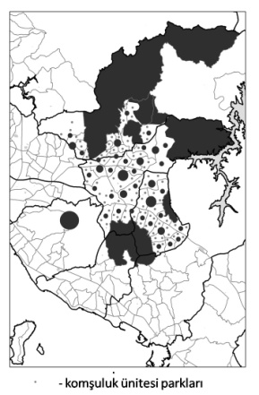
Source: APA Format.

2.1. Subheading

2.2. Subheading

3. HEADING

3.1. Subheading

3.2. Subheading

4. RESULTS AND DISCUSSION

REFERENCES

All references cited in the text should be shown under the title “References” at the end of the study. References should be given alphabetically (according to the surnames of the authors) and in their original language at the end of the article.
BNEJSS follows APA format as citation system. APA rules are also valid for giving references (Click here for APA examples).

